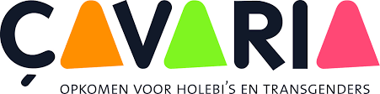

Çavaria – the umbrella of LGBTQ associations

In Flanders, there are more than 120 associations and organisations that deal with LGBTQ people in one way or another. One of the best known and most important associations is Çavaria, the umbrella of LTBQ associations in Flanders and Brussels.

On the website of the association, their mission is formulated as follows: “Çavaria inspires, stimulates and supports associations and individuals who speak up for a broad view on sexual orientation, gender expression and gender identity. It strives for individual wellbeing and stands up for the rights of homosexuals, lesbians, bisexuals and transgender people in all aspects of daily life.” (Çavaria)

The organisation offers support, participation and education to over 120 joined associations. Together, these associations form the LGBTQ community. Furthermore, equal opportunity activities focus on the entire society. The association campaigns, informs, sensitizes, lobbies and forms people’s opinions. The association has the anonymous “Holebifoon” (a hotline for LGBTQ people) and regularly publishes the magazine ZiZo. (Çavaria)

The association offers high-quality further training to educational staff. Part of their initiatives are training sessions such as “Diversity: a challenge for the school” or “An LGBTQ-friendly society starts at primary school”. How can the topic of sexual orientation be raised in class? There is a lot of material for this as well. Çavaria is also one of the associations that develops lesson material about LGBTQ topics.

https://cavaria.be/informatie

https://www.facebook.com/cavariapost

https://twitter.com/cavariatweet

https://www.youtube.com/user/cavariakijkt

